## The Road Arc Tool

This tool allows you to create a precise arc in a road with ease. As you can see in the images below, it is created from a radius.

**To create a Road Arc:**

* Select the **Arc Road** tool in the Roads tab of the Tools palette
* Click once to set the radius of the road arc
* The second click is where you start drawing your road arc from
* Now drag your cursor in the direction you want the road
* Click to place the road
* Right click to drop the tool
* 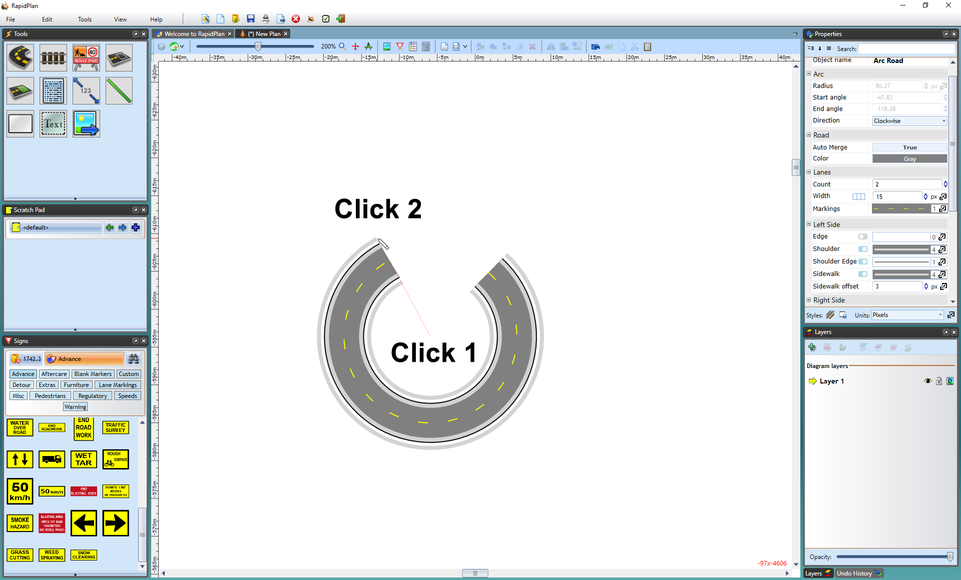
* Arc_Road

You can also choose to set the arc’s radius, angle and direction manually in the **Arc** tab of the Properties Palette.

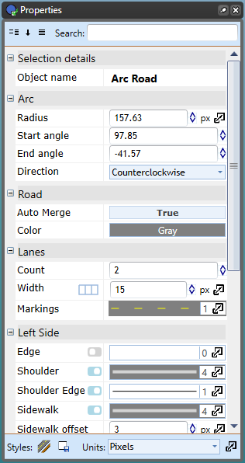

Arc_Road_Properties